Assignment No:01
Aim : Study of Wired and Wireless Communication

Theory :

1. Wired Communication
Wired communication refers to the transmission of data between devices using physical cables or conductors. The signals are transmitted through electrical or optical signals in the cable. Wired communication is known for its high reliability, high speed, and secure data transfer because the signals travel through a controlled physical medium.
Wired communication is widely used in computer networks, telephone systems, industrial control systems, and internet infrastructure. It is less affected by environmental interference compared to wireless communication.
Types of Wired Communication
1. Twisted Pair Cable
Twisted pair cables consist of two insulated copper wires twisted together to reduce electromagnetic interference. They are commonly used in telephone lines and Ethernet networks.
Types of Twisted Pair:
- UTP (Unshielded Twisted Pair) – Used in LAN networks
- STP (Shielded Twisted Pair) – Provides extra protection from interference

2. Coaxial Cable
Coaxial cable consists of a central conductor surrounded by insulation, a metallic shield, and an outer protective layer. It provides better protection from noise and interference.

3. Optical Fiber Cable
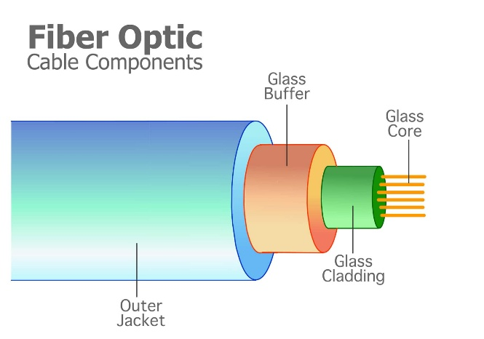
Optical fiber communication uses light signals instead of electrical signals to transmit data through thin glass or plastic fibers. It provides extremely high speed and long-distance communication.

Advantages
- High data transmission speed
- Reliable and stable communication
- Less signal interference
- More secure communication

Disadvantages
- Limited mobility
- Installation cost can be high
- Requires physical connection between devices

Applications

- Internet backbone networks
- Telecommunication systems
- Medical imaging devices

2. Wireless Communication
Theory
Wireless communication is the transmission of data between devices without using physical cables. Instead, it uses electromagnetic waves such as radio waves, microwaves, or infrared signals to transfer information.
Wireless communication allows devices to communicate over long distances and provides mobility and flexibility. It is widely used in mobile phones, Wi-Fi networks, satellite communication, and Bluetooth devices.

Advantages
- Mobility and flexibility
- Easy installation
- No need for physical cables
- Suitable for remote locations
Disadvantages
- Susceptible to interference
- Lower security compared to wired communication
- Signal strength may vary

Types of Wireless Communication
1. Radio Wave Communication
Radio waves are used for long-distance wireless communication. They can travel through the air and penetrate walls and buildings.
Applications
- Radio broadcasting
- Television broadcasting
- Mobile communication

2. Microwave Communication
Microwave communication uses high-frequency electromagnetic waves to transmit data. It requires a line-of-sight path between transmitting and receiving antennas.
Applications
- Satellite communication
- Radar systems
- Long-distance telephone communication

3. Infrared Communication
Infrared communication uses infrared light waves to transmit data over short distances.
Applications
- TV remote controls
- IR sensors
- Short-range device communication

4. Bluetooth Communication
Bluetooth is a short-range wireless technology used to connect devices such as headphones, keyboards, and smartphones. Range: Around 10 meters

5. Wi-Fi Communication
Wi-Fi is a wireless networking technology used to connect devices to the internet using radio waves.
Applications
- Home networks
- Offices
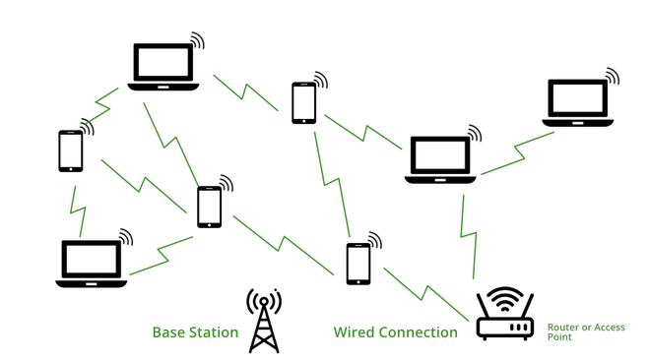
- Public internet hotspots

Conclusion
Wired and wireless communication systems play an essential role in modern technology. Wired communication provides stable, secure, and high-speed data transmission, while wireless communication offers flexibility and mobility. Both methods are widely used in various applications such as networking, telecommunications, and automation systems.

Assignment No:02

Aim : Study of Various Types of Sensors

Theory :

1. Temperature Sensor (LM35)

A temperature sensor is used to measure the temperature of an environment and convert it into an electrical signal. The LM35 temperature sensor is a widely used analog sensor whose output voltage is directly proportional to the temperature in degrees Celsius.

The LM35 sensor provides an output of 10 mV per °C, which means if the temperature is 30°C, the output voltage will be approximately 300 mV.

Temperature sensors are important in applications where temperature monitoring and control are required.

Applications

Weather monitoring systems

Industrial temperature control

Home automation systems

Medical devices

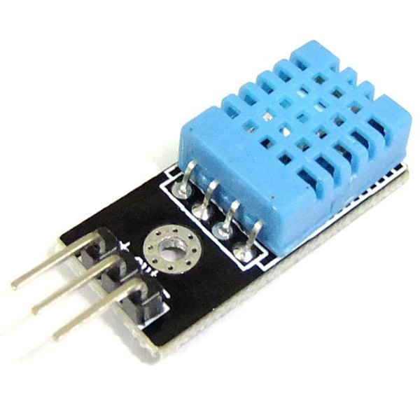
Diagram:

2. Infrared (IR) Sensor

An Infrared sensor detects objects by emitting infrared radiation and measuring the reflected radiation. It usually consists of two main components:

IR Transmitter (IR LED)

IR Receiver (Photodiode or Phototransistor)

When an object comes in front of the sensor, the infrared light emitted by the transmitter reflects from the object and is detected by the receiver. The sensor then converts this reflected signal into an electrical signal.

IR sensors are widely used for object detection, motion detection, and obstacle avoidance systems.

Applications

Obstacle detection in robots

Automatic door systems

Line follower robots

Remote control systems

Diagram:
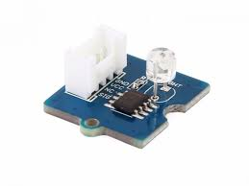

3. Ultrasonic Sensor

An ultrasonic sensor measures the distance of an object using ultrasonic sound waves. It works by sending high-frequency sound waves toward an object and measuring the time taken for the echo to return.

The distance is calculated using the formula:

Distance = (Speed of Sound × Time) / 2

Ultrasonic sensors are very useful for non-contact distance measurement.

Applications

Parking assistance systems

Robotics

Distance measurement

Water level detection

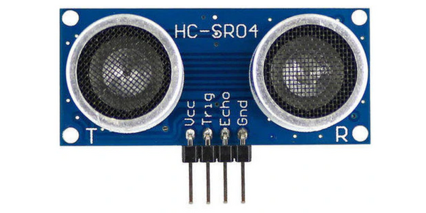
Diagram:

4. Gas / Smoke Sensor (MQ-2)

The MQ-2 sensor is used to detect gases such as LPG, methane, propane, and smoke. It contains a sensitive material that changes its electrical resistance when exposed to certain gases.

When gas concentration increases, the resistance of the sensor decreases, which produces a change in output voltage. This change can be detected by a microcontroller or alarm system.

Gas sensors are widely used in safety systems to detect gas leakage or fire hazards.

Applications

Gas leakage detection

Fire detection systems

Industrial safety systems

Air quality monitoring

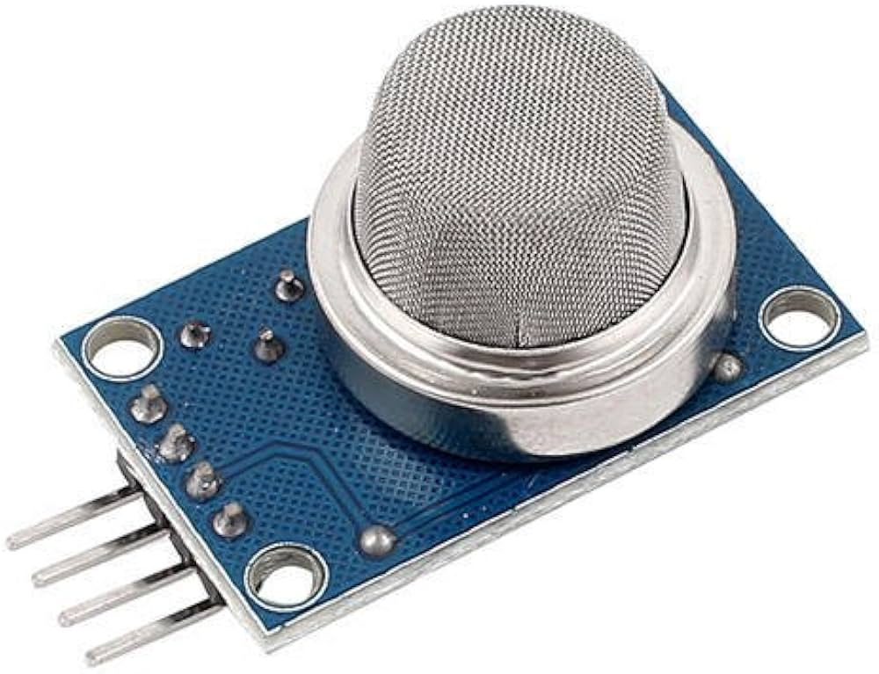
Diagram:

5. Light Dependent Resistor (LDR)

Theory

A Light Dependent Resistor (LDR) is a type of resistor whose resistance changes depending on the intensity of light falling on it.

In bright light, resistance decreases.

In darkness, resistance increases.

LDR sensors are used to detect light levels and automatically control lighting systems.

Applications

Automatic street lights

Camera light meters

Solar tracking systems

Light intensity measurement

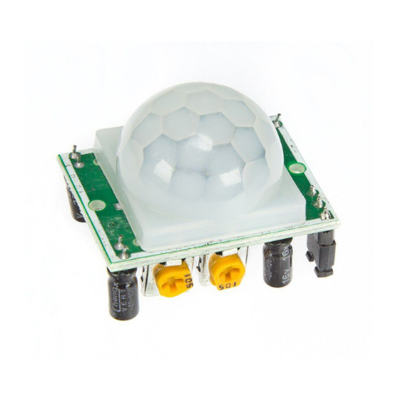
Diagram:

Conclusion:
In this experiment, different types of sensors and communication methods were studied. Sensors play an important role in detecting physical parameters such as temperature, light, gas, and distance. These sensors are widely used in automation, safety systems, robotics, and industrial applications.

